Flute Fingering Chart
Stephanie Rea

Many alternate fingerings are not listed on this here. I highly recommend Nestor Herszbaum’s exceptional Alternative Fingerings For the Flute.

L1 Left Hand Index Finger R1 Right Hand Index Finger
L2 Left Hand Middle Finger R2 Right Hand Middle Finger
L3 Left Hand Ring Finger R3 Right Hand Ring Finger
L4 Left Hand Pinky R4 Right Hand Pinky

Note | Fingering | Info
THE | LOW | REGISTER
Remember to use slow/close air. Don’t push the air too far. | Only use as much tension in the embouchure as you need to resist the air and to direct it at the edge. | Use friction in your air stream to blow gently but with energy. If the aperture is too large, it will be airy.
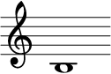
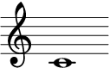
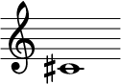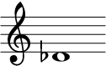
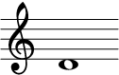

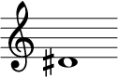
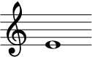 |  | Must have R4 down.
 |  | Do not use R2.
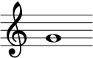
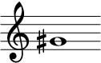
Standard fingering.

Use thumb Bb key in most flat keys. Should use this by 3rd year of playing and learn to change between standard and thumb Bbs.
 | This note is notoriously sharp. Make sure to aim air down at lower edge enough that you aren’t blowing sharp. Use a tuner. | Balance of the flute between three points is key here. Flute must rest gently on right thumb, on left lowest knuckle on index finger and chin. If you balance with your pinky, you have to stop balancing there when you have to lift R4. Don’t balance with R4.
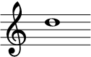 |  | No R4. No L1.
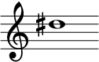 |  | No R4. No L1.
THE | PRIME | CRACK ZONE
Beware, the prime crack zone! | Aim air up a bit. The prime crack zone are all overblown octaves. | The more of the tube that is closed off (like middle E), the more likely it is to crack.
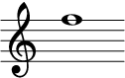
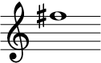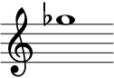 |  | Do not use R2.
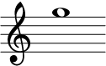
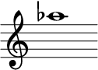
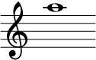
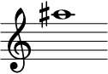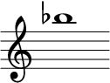 |  | Standard fingering.  Use thumb Bb key in most flat keys. Should use this by 3rd year of playing and learn to change between standard and thumb Bbs.
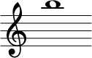
THE | HIGH | REGISTER
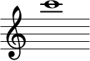
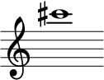  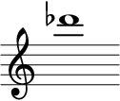 | This note is notoriously sharp. Make sure to aim air down at lower edge enough that you aren’t blowing sharp. Use a tuner. | Balance of the flute between three points is key here. Flute must rest gently on right thumb, on left lowest knuckle on index finger and chin. If you balance with your pinky, you have to stop balancing there when you have to lift R4. Don’t balance with R4.
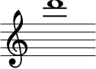
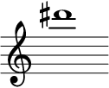
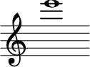 |  | Standard fingerings.  Because the standard fingering cracks so easily without a split E, most professionals use this better fingering most of the time.  This also brings pitch down.
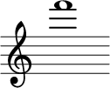 |  | Standard.  Brings pitch down.
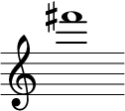  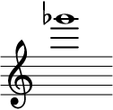 |  | Standard fingering.  Many flutists find this fingering more stable and less prone to cracking. Do NOT use R2 in the lower octaves. Also brings pitch down.
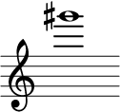  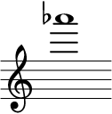 |  | Standard fingering.  This fingering brings the pitch down considerably and is best for forte.
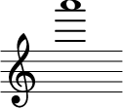 |  | Standard.  Brings pitch up and makes response easier on p.
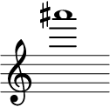  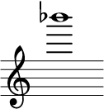 |  | Standard.  No L1. Many people learn this fingering incorrectly. Be aware that it is a little on the flat side of intonation.  For pp, use this fingering.
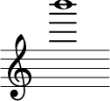 |  | Many books list the D# key as down. I find it responds better without.
THE | ALTISSIMO | REGISTER
Make sure you are not covering too much. If you do, it will not work at all. | Good news: uncovering the embouchure hole improves sound in the rest of the flute! | You must blow air very far, quite forcefully at first, to get these notes to speak.
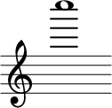 |  | If you have a low B, it must be down. If not, you can place R4 on low C or leave it up.
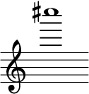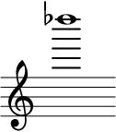 |  | Low B could stay down or be up.
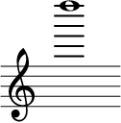 |  | Easy to remember: thumb, 3, 1, 2, C.
